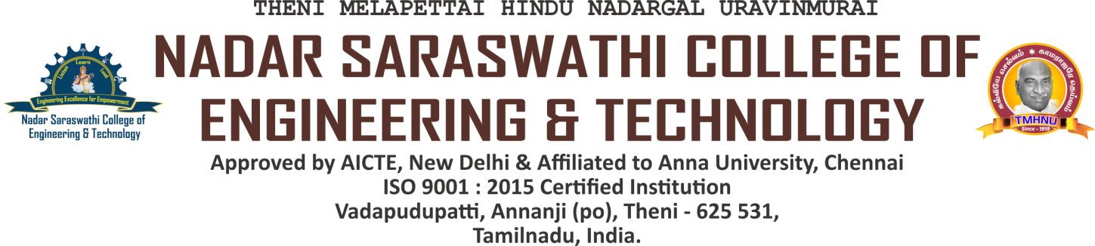

FEEDBACK POLICY

High-quality instruction in a pleasant atmosphere is consistently offered at Nadar Saraswathi College of Engineering and Technology. In order to do this, NSCET has modified a feedback system that gathers ideas from various stakeholders, including employers, teachers, alumni, and students from each program for every academic year. The completed feedback forms will be distributed to all stakeholders, and they will be collected. The action report is sent to the relevant bodies once the analysis of the feedback collected, important proposals from the stakeholders, and essential actions have been carried out.

FEEDBACK PROCESS

Stakeholders to Collect Feedback:
- Students
- Teachers
- Alumni
- Employers
- Every year, Stakeholder Questionnaires will be updated on need basis.
- Feedback forms are created based on curriculum and college ambiences.
- Regularly, feedback is collected from the stakeholders.
- Students, teachers and employers – Online / Allowed Specific Timeline.
- Alumni - Online / Alumni Meet (Every Year)

- The stakeholders are asked to fill the form and give the remarks (Excellent, Very Good, Good and Poor) and Suggestions.
- The feedback given by the stakeholders is consolidated and analysed. The report is generated stakeholder wise and reviewed in department meeting.
- For each question, target has been set before the collection of feedback. From the analysis report all the suggestions given by the stakeholders are forwarded to the department advisory committee and also recommended to take necessary actions for the questions below target to meer the industry requirements and real time problem solving skills.

FEEDBACK PROCESS | REMARKS
Feedback Collection | Applicable to all courses and collected through offline during Alumni meet and regular academic schedule.
Feedback Receiver | Head of the Department
Frequency of the Feedback Collection | Once in a Year
Metrics used for Calculation | 5 – Excellent, 4 – Very Good, 3 – Good, 2 – Satisfactory, 1 – Poor
Target | 80 % Excellent and Very Good
Action Taken / Corrective measures taken | Below 80 % and suggestions provided in comments.

CONSOLIDATION AND CORRECTIVE ACTIONS TAKEN

- IQAC has created a committee to evaluate the feedback reviewed by the Departments.
- Training is conducted by various sources through NSCET Placement Cell to enhance students’ knowledge in trending technologies.
- All departments conduct various ADD ON Programs for the development of students.
- All departments arrange Industrial Visits to get exposure on real time applications and work environments.
- All the required facilities were provided to the faculty and the students to complete online courses like NPTEL, SWAYAM etc.
- Additional classes were provided to the students (acadmic weak students) to make them confident and achieve better results in analytical papers for Anna University Examinations.

